STAT 601

--Assignment 6

NAIQING CAI

Ncai5@wisc.edu

1. Analyze the data and write a brief report.

We can find that y (number of children applied for LEP), is from poisson distribution. Thus, we fit it in a log linear poisson regression model.

1. Fit a log linear poisson regression model with one factor as follows:
2. **Y~SES**



1. **Y~mental health**



1. Fit a log linear poisson regression model with two factors as follows:
2. **Y~SES+ mental health**



1. **Y~SES+ mental health + SES:mental health**



|  |  |  |
| --- | --- | --- |
| Model | Deviance | df |
| Null | 217.4 | 23 |
| One Factor Models |  |  |
| SES | 160.943 | 18 |
| Mental | 103.87 | 20 |
| Two Factor Models |  |  |
| SES+Mental | 47.418 | 15 |
| SES+Mental+SES:Mental | 0 | 0 |

Table 1.1 Deviances for the poisson log-linear model

**General Observations**

Null model has a deviance of 217.4 on 23 degree of freedom, which does not pass the goodness of test, so we should reject the null hypothesis. The null model is not good.

Then, introducing the SES and Mental both lead to substantial deviance reduction on a small degree of freedom, so the p-value is small enough to reject the null hypothesis. In this way, we can say that SES and Mental are both significant in the model. The number of applications will be effected both by mental health status and SES. So,we add these two items into the model.

The additive model Y~SES+ mental health + SES:Mental health has a deviance of 0 on 0 degree of freedom and the associated p-value is really small. In this way, the additive model provides a good description of the data. So, we need to add the interactions into the model.

**Detailed Observations**

Based on the table attached in the appendix, since the coefficient for “mild mental” is 0.71465 larger than the reference term “good mental”, we find that LEP receive a higher volume of applications from children with mild mental status, compared to children with good mental status.

Also, there is some interaction between particular levels of SES and mental health status, the most significant ones at 5% level are SESE:mentalMild, SESF:mentalMild, SESE:mentalModerate , SESD:mentalWell, SESE:mentalWell and SESF:mentalWell since the p-value for their coefficients is really small so they are significant in the model. (The result is attached in the appendix) This also means that the interactions are essential part of the model.

2. In the Bradley-Terry model for ranking k competitors, parameters θ1,...,θk representing ‘abilities’ are introduced in such a way that the probability πij that competitor i beats j is a function of the difference in their abilities.

(a) Write out the 21 × 7 model matrix X for the Bradley-Terry model.

In the logit model, we have



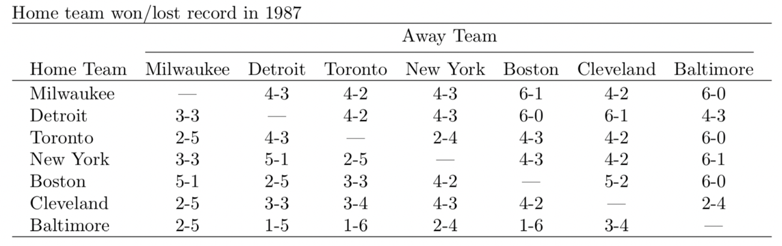

Table 2.1 Home-team win/lose record

|  |  |  |  |
| --- | --- | --- | --- |
| team Milwaukee: 1 | team Detroit: 2 | team Toronto:3 | team New York: 4 |
| team Boston: 5 | team Cleveland: 6 | team Baltimore: 7 |  |

Table 2.2 Index for each team

|  |  |  |  |  |  |  |  |
| --- | --- | --- | --- | --- | --- | --- | --- |
| Pairs\competitors | Θ1 | Θ2 | Θ3 | Θ4 | Θ5 | Θ6 | Θ7 |
| Milwaukee Detroit | 1 | -1 | 0 | 0 | 0 | 0 | 0 |
| Milwaukee Toronto | 1 | 0 | -1 | 0 | 0 | 0 | 0 |
| Milwaukee New York | 1 | 0 | 0 | -1 | 0 | 0 | 0 |
| Milwaukee Boston | 1 | 0 | 0 | 0 | -1 | 0 | 0 |
| Milwaukee Cleveland | 1 | 0 | 0 | 0 | 0 | -1 | 0 |
| Milwaukee Baltimore | 1 | 0 | 0 | 0 | 0 | 0 | -1 |
| Detroit Toronto | 0 | 1 | -1 | 0 | 0 | 0 | 0 |
| Detroit New York | 0 | 1 | 0 | -1 | 0 | 0 | 0 |
| Detroit Boston | 0 | 1 | 0 | 0 | -1 | 0 | 0 |
| Detroit Cleveland | 0 | 1 | 0 | 0 | 0 | -1 | 0 |
| Detroit Baltimore | 0 | 1 | 0 | 0 | 0 | 0 | -1 |
| Toronto New York | 0 | 0 | 1 | -1 | 0 | 0 | 0 |
| Toronto Boston | 0 | 0 | 1 | 0 | -1 | 0 | 0 |
| Toronto Cleveland | 0 | 0 | 1 | 0 | 0 | -1 | 0 |
| Toronto Baltimore | 0 | 0 | 1 | 0 | 0 | 0 | -1 |
| New York Boston | 0 | 0 | 0 | 1 | -1 | 0 | 0 |
| New York Cleveland | 0 | 0 | 0 | 1 | 0 | -1 | 0 |
| New York Baltimore | 0 | 0 | 0 | 1 | 0 | 0 | -1 |
| Boston Cleveland | 0 | 0 | 0 | 0 | 1 | -1 | 0 |
| Boston Baltimore | 0 | 0 | 0 | 0 | 1 | 0 | -1 |
| Cleveland Baltimore | 0 | 0 | 0 | 0 | 0 | 1 | -1 |

Table 2.3 21 × 7 model matrix X for the Bradley-Terry model

(b) Fit the Bradley Terry model to these data to obtain a ranking of the teams. Extend this model by including a home-team advantage effect (equal for all teams). Obtain the likelihood-ratio statistic. Comment briefly on the magnitude of home-field advantage.

**Fit the Bradley Terry model**





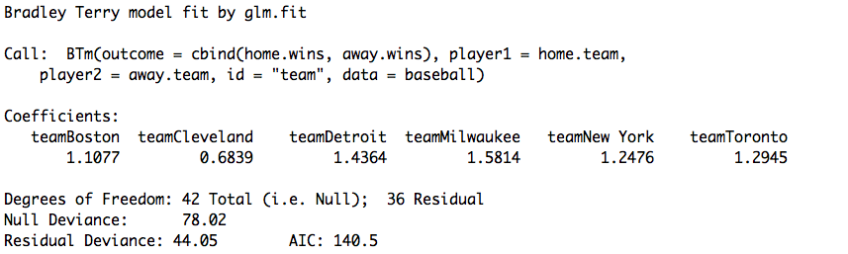

Table 2.4 Coefficients for Bradley Terry model

Then, we get the formula for the model:



The coefficients here are maximum likelihood estimates of Θi (i=2,3,4,5,6,7) with Θ1 (the log-ability for Baltimore) set to zero as an identifying convention.

The coefficients represent each team’s ability that the probability πij that competitor i beats j is a function of the difference in their abilities.

In the model, the reference team is Baltimore, estimated to be the weakest of these seven, with Milwaukee and Detroit the strongest.

**Ranking of the teams**

Based on the results, we can rank each teams with by their coefficient estimates.

|  |  |
| --- | --- |
| 1 | Milwaukee |
| 2 | Detroit |
| 3 | Toronto |
| 4 | New York |
| 5 | Boston |
| 6 | Cleveland |
| 7 | Baltimore |

Table 2.5 Ranking of teams (from high to low)

**Model Extension**

In order to extend the model, we need to add the home advantage as another explanatory variable.



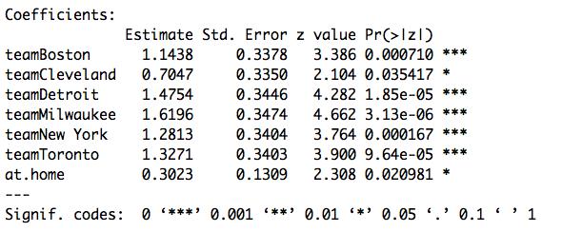

Table 2.6 Extended Bradley Terry model



**Obtain the likelihood-ratio statistic**

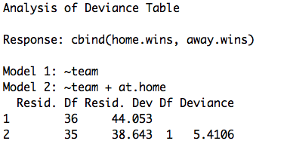

Table 2.7 Anova table of likelihood ratio test

Based on the likelihood ratio test, we can find the likelihood ratio statistic and its p value.



p-value= 0.02<0.05, so the home term should not be removed from the model since it is significant.

**Comment on the Magnitude of home-field advantage**

Based on the table above, we can find that the p-value of at.home = 0.02<0.025. So we conclude that the coefficient of at.home is not equal to 0, and home-field has an effect on the success probability of each team.

In this sense, the home team has an estimated odds-multiplier of exp(0.3023) = 1.35 in its favour.

(c) Estimate the probability that Detroit beats Boston

(i) at Boston

We take Boston=1, home=1

We take Detroit =1, home=0





So the probability that Detroit beats Boston is 0.5073

(ii) at Detroit

We take Boston=1, home=0

We take Detroit =1, home=1





So the probability that Detroit beats Boston is 0.6534

(iii) on neutral territory.

We take Boston=1, home=0

We take Detroit =1, home=0





So the probability that Detroit beats Boston is 0.58215

(d) Does the extended model fit the data? Comment briefly on any patterns in the residuals.

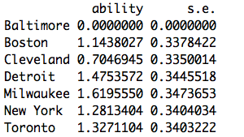

Table 2.8 Ability of extended model

Based on the above model, we can find that the ability of the extended model is good. So, it fits the data well.

**Comments on residuals pattern**

../../Rplot02.pdf

Figure 2.9 Residual Patterns

(1) Normal distribution: Based on the qq-plot, we can find that the assumption that residuals are from normal distribution is satisfied.

(2) Equal variance: Based on the residuals v.s fitted values plot, we can find that the assumption that equal variance is not also satisfied. In this way, we’d better to do some transformation to the data.

../../Rplot03.pdf

Figure 2.10 Scatterplot of Residuals

(3) Independence: Based on the scatterplot above, we can conclude that the residuals are independent with each other so that the assumption of independence are satisfied.

3. Table 1 gives the mean number of children born per woman, the women being classified by place, education, and years since first marriage. Any systematic variation in the number of children is of interest. See fiji.txt for the dataset.

(a) Fit an appropriate model describing how the number of children varies with marital age, mother’s abode and education. Give a brief synopsis of the arguments justifying your formulation and choice of model, including checks for model adequacy.

**Fit an appropriate model**







Thus, we can fit the model as follows:



**Give a brief synopsis of the arguments**









In this way, then we can analyze the data by fitting the **poisson model** to group totals.

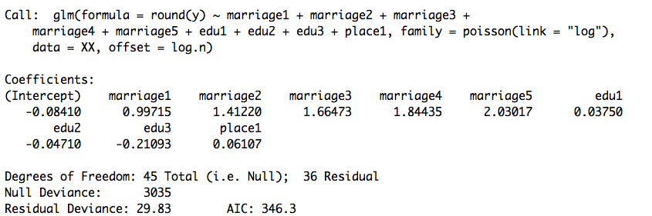

Table 3.1 Log-linear poisson model

Based on the r summary table, we can get the formula as follows:



**Checks for model adequacy (assumption)**

We need to check the following to terms:

1. Independent

../../independent.pdf

Figure 3.2 Scatterplot of Residuals

Based on the scatterplot above, we can conclude that the residuals are independent with each other so that the assumption of independence are satisfied.

1. Equal Variance & Normal distribution

../../checking.pdf

Figure 3.3 Checking Adequacy

Based on the qq-plot, we can find that the assumption that residuals are from normal distribution is satisfied.

Based on the residuals v.s fitted values plot, we can find that the assumption that equal variance is not satisfied since the variance of residuals are changed with the change of fitted values. In this way, we’d better to do some transformation to the data.

1. Model Extension

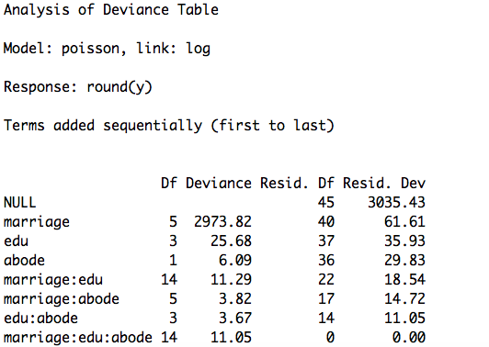

Table 3.4 Anova table for Extended Model

Based on the the anova table above, we can find that the interactions are not significant in the model, so we don’t need to put them in the model and the original model is adequate.

(b) Explain the meaning of all parameters in your model. Comment on the major factors affecting fertility.

**Meaning of all parameters**

















**Comment**

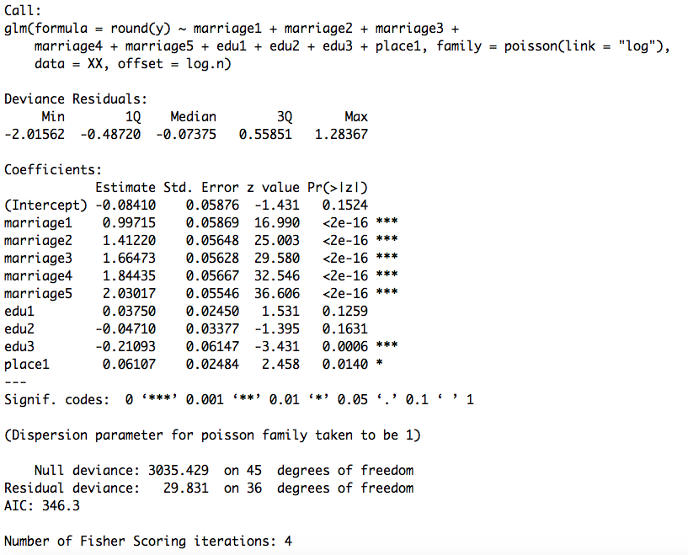

Table 3.5 Estimates for log-linear poisson model

Based on the table above, we can make a comment on the major factors affecting fertility.

**Major factors are:**

Marriage is the most effective factor among the three factors. Also, women with marriage years over 25years will have the highest fertility. That is said, the longer the marriage, the more the children to be born.

Education (secondary education) is the second effective factor. Women with highest level education will have least children than the other three kinds of education levels. That is said the higher the education level, the less the children to be born.

Place is the least effective factor. For this factor, women in rural will have more children than those in urban.

(c) Construct a 95% confidence interval for the mean number of children born to an urban woman with upper elementary education after ten years of marriage.

**For 10-14 years:**

"marriage1"=0,"marriage2"=1,"marriage3"=0,"marriage4"=0,"marriage5"=0,"edu1"=0,"edu2"=1,

"edu3"=0,"place1"=0,"log.n"=0

**95% confidence interval**









**For 15-19 years:**

"marriage1"=0,"marriage2"=0,"marriage3"=1,"marriage4"=0,"marriage5"=0,"edu1"=0,"edu2"=1,"edu3"=0,"place1"=0,"log.n"=0

**95% confidence interval**



**For 20-24 years:**

"marriage1"=0,"marriage2"=0,"marriage3"=0,"marriage4"=1,"marriage5"=0,"edu1"=0,"edu2"=1,

"edu3"=0,"place1"=0,"log.n"=0

**95% confidence interval**



**For 25+ years:**

"marriage1"=0,"marriage2"=0,"marriage3"=0,"marriage4"=0,"marriage5"=1,"edu1"=0,"edu2"=1,

"edu3"=0,"place1"=0,"log.n"=0

**95% confidence interval**



(d) Estimate the lifetime average number of children born to rural women with secondary education. Give 90% confidence limits.

Based on the context, we take new dataset as

"marriage1"=0,"marriage2"=0,"marriage3"=0,"marriage4"=0,"marriage5"=1,"edu1"=0,"edu2"=0,"edu3"=1,"place1"=1,"log.n"=0

**90% confidence interval**



4. The file byss.txt contains information, obtained from a survey conducted by a large textile company, on the prevalence of byssinosis, a lung disease to which cotton workers are subject. The file lists the observed prevalence of byssinosis (affected, not affected), by race (white = 1; non white = 2), sex (male = 1; female = 2), smoking habits (two levels), length of employment (three levels), and dustiness of the work environment (three levels). In the last three cases, higher-numbered categories denote larger values (more smoking, longer employment and increased dustiness). Parts (a) and (b) are based on the assumption that the main-effects linear logistic model is substantially correct.

(a) Fit the main-effects linear logistic model. Explain how the residual degrees of freedom is calculated for the deviance.

**Fit the model**



**Explanatory Variables:**

Race=1, if non-white, otherwise 0

Sex=1, if female, otherwise 0

Smoking habit=1, if =2, otherwise 0

Employment1=1, if =2, otherwise 0

Employment2=1, if =3, otherwise 0

Dustiness1=1, if=2, otherwise 0

Dustiness2=1, if=3, otherwise 0

Then we can have the result as follows:

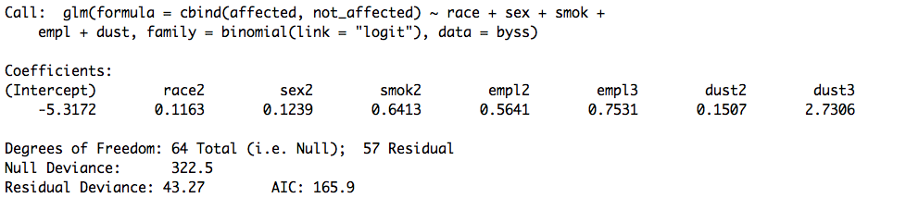

Table 4.1 Linear Logistic Model

Based on the above table, we can find that the linear logistic model is the following form:



**Explanation**

Residual degrees of freedom is 57 is which is calculated for the residual deviance is 43.27.

Null degrees of freedom is 64 which is calculated for the null deviance is 322.5.

Thus, we can find that:

residual degrees of freedom(64) = null degree of freedom(57) - # of parameters (8) +1

(b) Interpret the coefficient of sex(2). Construct an approximate 90% confidence interval for the odds ratio (males vs females) of contracting byssinosis.

**Interpret the coefficient of sex(2)**

sex(2) means female, coefficient of sex(2) is beta2 in the model.



Beta2 represents the the difference between log(odds) for female and log(odds) for male in prevalence of byssinosis.

**90% confidence interval**









So the 90% confidence interval for the odds ratio (males vs females) of contracting byssinosis is the 90% confidence interval for the coefficient **exp(beta2)**.

90% confidence interval for beta2: (-0.2565643, 0.4973715)

90% confidence interval for exp(beta2): (0.7737052, 1.644393)

(c) Drop the least significant factor from the model, proceeding until all the remaining factors are significant at the 5% level. Interpret the reduced model thus obtained.

**Drop the least significant factor**

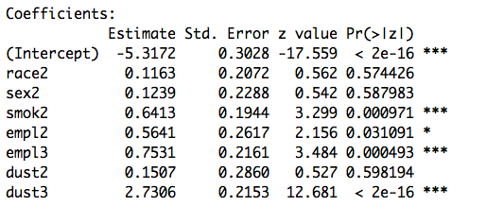

Table 4.2 Full model

Based on the above table, we find that the least significant factor is sex2. So we drop it from the model.

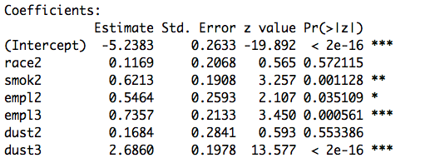

Table 4.3 Drop step one

Based on the above table, we find that the least significant factor is race2. So we drop it from the model.

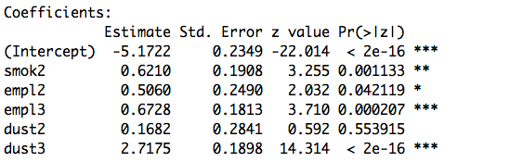

Table 4.4 Drop step two

**Interpret the reduced model**

Now, all the remaining factors are significant at the 5% level.

The remaining model is:



Parameters:

Intercept: representing log(odds) for group (white, male, smoke habit level=1, employment level=1, dust level=1), which is -5.1722

Coefficient of smoking habit: representing difference between log(odds) for smoke habit level=2 and log(odds) for smoke habit level=1

Coefficient of employment2: representing difference between log(odds) for employment level=2 and log(odds) for employment level=1

Coefficient of employment3: representing difference between log(odds) for employment level=3 and log(odds) for employment level=1

Coefficient of dust2: representing difference between log(odds) for dust level=2 and log(odds) for dust level=1

Coefficient of dust3: representing difference between log(odds) for dust level=3 and log(odds) for dust level=1

(d) Beginning with the complete main-effects model, look for significant interactions by fitting each of the ten models main effects + one interaction. In judging the significance of interactions, you should bear in mind, at least informally, the effects of selection. After detecting the significant interactions, remove insignificant main effects as described in (c), except for those that are included in interactions. Interpret the model thus obtained.

**Fitting each of the ten models main effects + one interaction**

Complete main-effects model



1st model: main effects + race*sex

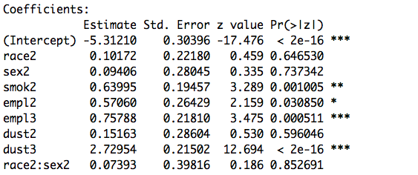

The coefficient of race*sex is 0.0739, and p-value is 0.8527>0.05.

So it is insignificant interaction and should be removed.

2nd model: main effects + race*smoking habit

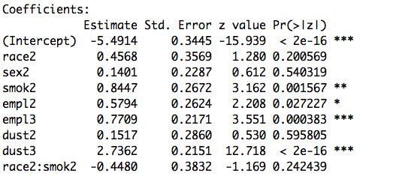

The coefficient of race*smoking habit is -0.448, and p-value is 0.2424>0.25.

So it is insignificant interaction and should be removed.

3rd model: main effects + race*employment

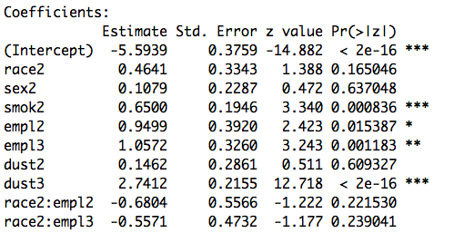

The coefficient of race*employment are -0.6804 and -0.5571, and p-value are 0.2215>0.05 and 0.239>0.05. So it is insignificant interaction and should be removed.

4th model: main effects + race*dustiness

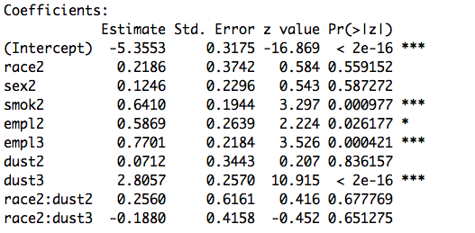

The coefficient of race*dustiness are 0.2560 and -0.188, and p-value are 0.678>0.05 and 0.65 > 0.05.

So it is insignificant interaction and should be removed.

5th model: main effects +sex* smoking habit

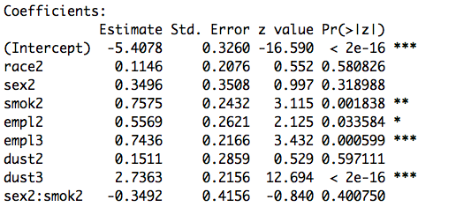

The coefficient of sex* smoking habit is -0.3492, and p-value is 0.4001>0.05.

So it is insignificant interaction and should be removed.

6th model: main effects + sex*employment

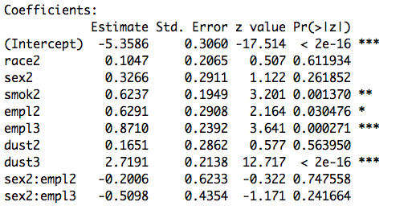

The coefficient of sex*employment are -0.2 and -0.51, and p-value are 0.748>0.05 and 0.242>0.05.

So it is insignificant interaction and should be removed.

7th model: main effects + sex* dustiness

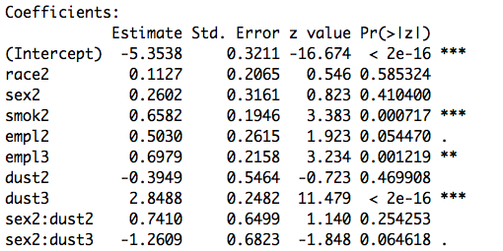

The coefficient of sex* dustiness are 0.741 and -1.261, and p-value are 0.254>0.05 and 0.065<0.1.

So sex2*dust2 is insignificant interaction and should be removed.

But sex2*dust3 is significant interaction and should be added to the model.

8th model: main effects + smoking habit*employment

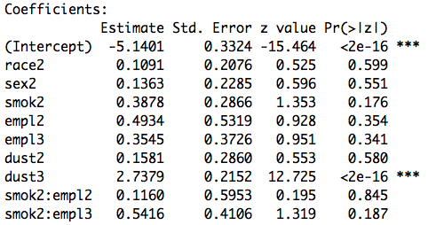

The coefficient of smoking habit*employment are 0.116 and 0.542, and p-value are 0.845>0.05 and 0.187>0.05.

So it is insignificant interaction and should be removed.

9th model: main effects + smoking habit*dustiness

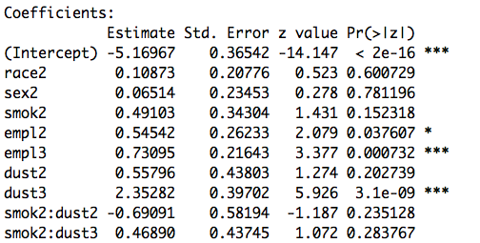

The coefficient of smoking habit*dustiness are -0.6901 and 0.4689, and p-value are 0.2351>0.05 and 0.2838>0.05.

So it is insignificant interaction and should be removed.

10th model: main effects + employment*dustiness

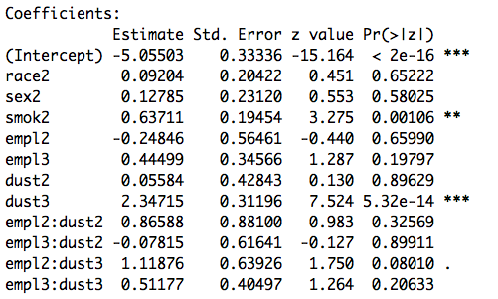

The coefficient of employment*dustiness habit are 0.8659, -0.078, 1.1188 and 0.512, and p-value are 0.33>0.05, 0.899>0.05, 0.08<0.1 and 0.21>0.05.

So empl2*dust3 is significant interaction and should be remained. The others should be removed.

**Final model with interaction**

Based on the above analysis, and the use the method described in (c), we conclude that we include sex, smoking habit, employment, dust and interaction dust*sex as explanatory variable in the final model since the anova table can show that it is the best adequate model. And then we can get the results as follows:



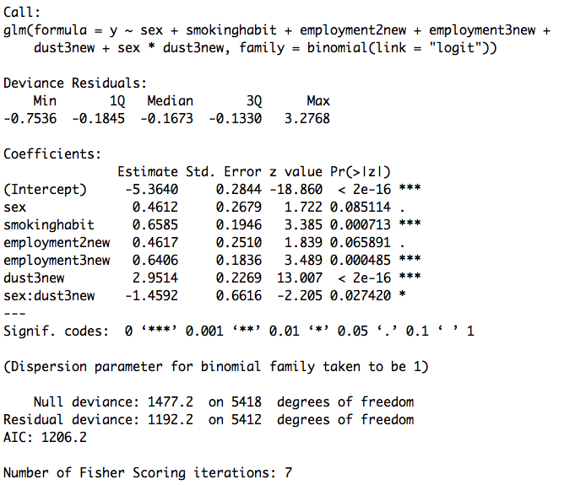

Table 4.5 Coefficients for the final model

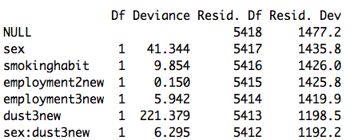

Table 4.6 Anova table for the final model

**Interpretation**

This model represents that sex, smoking habit, employment, dust and interaction dust*sex, these items are significant in the final model and they effect the response variable in a large degree.

(e) You are required to write a short report giving details of the excess risk associated with cotton dust. How fast does the risk increase with dust level? If necessary, give separate figures for males and females or for smokers and non-smokers.

1. **General Analysis**
2. Fitting the model

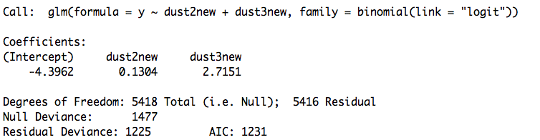

Table 4.7 Model y~dust2+dust3

Then we get the model as follows:



1. Analysis

Based on the model, we can calculate how fast does the risk increase with dust level.

The OR represents how fast the risk increase with dust level.

**For dust level=1 and dust level=2**



So the dust level=2 has 1.1393 times risk than dust level=1

**For dust level=2 and dust level=3**



So the dust level=3 has 13.259 times risk than dust level=2

**For dust level=1 and dust level=3**



So the dust level=3 has 15.106 times risk than dust level=1

1. **Categorical Analysis**
2. **For males and females**

../../Rplot.pdf

Figure 4.8 Dust v.s Risk in sex

Based on the above figures, we conclude that the increased dustiness will both affect (increase) the male and female’s risk of prevalence of byssinosis. But we can also see that the increasing level of dust will affect more strongly on male instead of female. This is say that male will increase the risk with the increase of dust level at a rate which is higher than that of female.

1. **For smokers and non-smokers**

../../Rplot01.pdf

Figure 4.9 Dust v.s Risk in smoking habit

Based on the above figures, we conclude that the increased dustiness will both affect (increase) the smoker and nonsmoker’s risk of prevalence of byssinosis. And the increasing level of dust will affect smokers slightly stronger than nonsmokers. This is say that smokers will increase the risk with the increase of dust level at a rate which is slightly higher than that of nonsmokers.

(f) Does this analysis suggest that the aetiology of byssinosis is related to sex or race? Explain.

Yes, some analysis suggests that the aetiology of byssinosis is related to sex. Since sex*dust is a significant interaction in the model, so the sex term should be remained in the model.

But the race itself and the interactions including it both have little significance in the model. So there is no analysis suggest that the aetiology of byssinosis is related to race.

Appendix

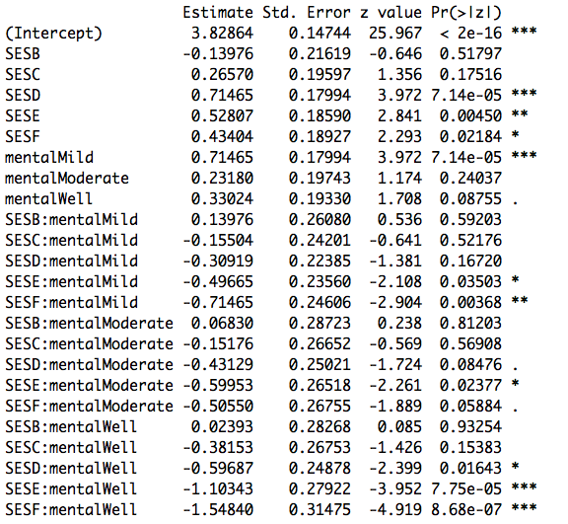

Figure: Summary R table for problem 1

|  |
| --- |
| #1  SES=c("A","A","A","A","B","B","B","B","C","C","C","C","D","D","D","D","E","E","E","E",  "F","F","F","F")  mental=c("Well","Mild","Moderate","Impaired","Well","Mild","Moderate","Impaired","Well","Mild","Moderate","Impaired","Well","Mild","Moderate","Impaired","Well","Mild","Moderate","Impaired","Well","Mild","Moderate","Impaired")  y=c(64,94,58,46,57,94,54,40,57,105,65,60,72,141,77,94,36,97,54,78,21,71,54,71)  #regression  glm1=glm(y~mental,family = poisson(link="log"))  summary(glm1)  glm2=glm(y~SES,family = poisson(link="log"))  summary(glm2)  glm11=glm(y~SES+mental,family = poisson(link="log"))  summary(glm11)  anova(glm11)  glm12=glm(y~SES+mental+SES*mental,family = poisson(link="log"))  anova(glm12)  summary(glm12) |
| #2  install.packages("BradleyTerry2")  library(BradleyTerry2)  data("baseball",package = "BradleyTerry2")  head(baseball)  #original model  baseballModel1=BTm(cbind(home.wins,away.wins),home.team, away.team,data = baseball,id="team")  baseballModel1  summary(baseballModel1)  #extended model  baseball$home.team=data.frame(team=baseball$home.team,at.home=1)  baseball$away.team=data.frame(team=baseball$away.team,at.home=0)  baseballModel2=update(baseballModel1,formula= ~ team+at.home)  summary(baseballModel2)  #Obtain the likelihood-ratio statistic  anova(baseballModel1,baseballModel2)  1-pchisq(5.4106,1)  #d  BTabilities(baseballModel1)  par(mfrow=c(2,2))  plot(baseballModel2,cex.lab=1.5,cex.main=1.5)  residual=residuals(baseballModel2)  par(mfrow=c(1,1))  plot(residual,main = "Scatterplot",cex.lab=1.5,cex.main=1.5) |
| #3  #a  #read data  fiji=read.table("fiji.txt",header = T)  fijinew=fiji[c(-24,-48),]  fijinew$marriage=factor(fijinew$marriage)  fijinew$edu=factor(fijinew$edu)  fijinew$abode=factor(fijinew$abode)  y=fijinew$tot*fijinew$average  log.n=log(fijinew$tot)  #model  glm1=glm(data=XX,round(y)~marriage1+marriage2+marriage3+marriage4+  marriage5+edu1+edu2+edu3+place1,offset=log.n,family = poisson(link="log"))  glmnew=glm(data=fijinew,round(y)~marriage+edu+abode,offset=log.n,family = poisson(link="log"))  glmnewnew=glm(data=fijinew,round(y)~marriage+edu+abode+marriage*edu+marriage*abode+edu*abode+marriage*edu*abode,offset=log.n,family = poisson(link="log"))  #checking  install.packages("MASS")  library(MASS)  install.packages("lmtest")  install.packages("nortest")  library(nortest)  library(lmtest)  library(base)  par(mfrow=c(2,2))  plot(glm1)  #scatterplot  par(mfrow=c(1,1))  plot(studres(glm1),ylab="residuals",xlab = "index",main = "scatterplot of residuals",cex.lab=1.5,cex.main=1.5)  ## fit vs res ##  plot(glm1$fitted.values ,studres(glm1),xlab="Fitted values",  ylab="Studentized residuals",  main="Residual vs Fitted",cex.lab=1.5,cex.main=1.5)  abline(h=0);abline(h=3,lty=2);abline(h=-3,lty=2)  ## res QQ ##  qqnorm(studres(glm1),ylab="Studentized residuals",  ylim=c(-2,2),cex.lab=1.5,cex.main=1.8)  qqline(studres(glm1))  #b  summary(glm1)  #c&d  #predict  pnew1=predict.glm(glm1,newdata = data.frame("marriage1"=0,"marriage2"=1,"marriage3"=0,"marriage4"=0, "marriage5"=0,"edu1"=0,"edu2"=1,"edu3"=0,"place1"=0,"log.n"=0), type="response",se.fit = T)  pnew2=predict.glm(glm1,newdata = data.frame("marriage1"=0,"marriage2"=0,"marriage3"=1,"marriage4"=0, "marriage5"=0,"edu1"=0,"edu2"=1,"edu3"=0,"place1"=0,"log.n"=0), type="response",se.fit = T)  pnew3=predict.glm(glm1,newdata = data.frame("marriage1"=0,"marriage2"=0,"marriage3"=0,"marriage4"=1, "marriage5"=0,"edu1"=0,"edu2"=1,"edu3"=0,"place1"=0,"log.n"=0), type="response",se.fit = T)  pnew4=predict.glm(glm1,newdata = data.frame("marriage1"=0,"marriage2"=0,"marriage3"=0,"marriage4"=0, "marriage5"=1,"edu1"=0,"edu2"=1,"edu3"=0,"place1"=0,"log.n"=0), type="response",se.fit = T)  pnew25=predict.glm(glm1,newdata = data.frame("marriage1"=0,"marriage2"=0,"marriage3"=0,"marriage4"=0,"marriage5"=1,"edu1"=0,"edu2"=0,"edu3"=1,"place1"=1,"log.n"=0), type="response",se.fit = T) |
| #4  #a  byss=read.table("byss.txt",header = T)  byss  length(byss$affected)  byss$race=factor(byss$race)  byss$sex=factor(byss$sex)  byss$smok=factor(byss$smok)  byss$empl=factor(byss$empl)  byss$dust=factor(byss$dust)  m1=glm(cbind(affected,not_affected)~race+sex+smok+empl+dust,data=byss,family = binomial(link="logit"))  summary(m1)  m2=glm(cbind(affected,not_affected)~race+smok+empl+dust,data=byss,family = binomial(link="logit"))  summary(m2)  m3=glm(cbind(affected,not_affected)~smok+empl+dust,data=byss,family = binomial(link="logit"))  summary(m3)  #d  glminter1=glm(cbind(affected,not_affected)~race+sex+smok+empl+dust+race*sex,data=byss,family = binomial(link="logit"))  glminter1$coefficients  summary(glminter1)  glminter2=glm(cbind(affected,not_affected)~race+sex+smok+empl+dust+race*smok,data=byss,family = binomial(link="logit"))  summary(glminter2)  glminter3=glm(cbind(affected,not_affected)~race+sex+smok+empl+dust+race*empl,data=byss,family = binomial(link="logit"))  summary(glminter3)  glminter4=glm(cbind(affected,not_affected)~race+sex+smok+empl+dust+race*dust,data=byss,family = binomial(link="logit"))  summary(glminter4)  glminter5=glm(cbind(affected,not_affected)~race+sex+smok+empl+dust+sex*smok,data=byss,family = binomial(link="logit"))  summary(glminter5)  glminter6=glm(cbind(affected,not_affected)~race+sex+smok+empl+dust+sex*empl,data=byss,family = binomial(link="logit"))  summary(glminter6)  glminter7=glm(cbind(affected,not_affected)~race+sex+smok+empl+dust+sex*dust,data=byss,family = binomial(link="logit"))  summary(glminter7)  glminter8=glm(cbind(affected,not_affected)~race+sex+smok+empl+dust+smok*empl,data=byss,family = binomial(link="logit"))  summary(glminter8)  glminter9=glm(cbind(affected,not_affected)~race+sex+smok+empl+dust+smok*dust,data=byss,family = binomial(link="logit"))  summary(glminter9)  glminter10=glm(cbind(affected,not_affected)~race+sex+smok+empl+dust+empl*dust,data=byss,family = binomial(link="logit"))  summary(glminter10)  #e  #dust and risk  plot(dust1,y)  plot(dust2,y)  glmdust=glm(y~dust2new+dust3new,family = binomial(link="logit"))  par(mfrow=c(1,1))  abline(glmdust)  curve(expr = exp(glmdust$coefficients[1]+glmdust$coefficients[2]*x)/(1+exp(glmdust$coefficients[1]+glmdust$coefficients[2]*x)),add = T)  #for sex  byss=read.table("byss.txt",header = T)  malerisk=c()  maledust=c()  femalerisk=c()  femaledust=c()  byss=read.table("byss.txt",header = T)  for (a in 1:length(byss$sex)){  if (byss$sex[a]==1){  maleriska=byss$affected[a]/(byss$affected[a]+byss$not_affected[a])  malerisk=c(malerisk,maleriska)  maledust=c(maledust,byss$dust[a])  } else{  femaleriska=byss$affected[a]/(byss$affected[a]+byss$not_affected[a])  femalerisk=c(femalerisk,femaleriska)  femaledust=c(femaledust,byss$dust[a])  }  }  par(mfrow=c(1,2))  plot(maledust,malerisk,main = "dust v.s risk for male",cex.lab=1.5,cex.main=1.5,ylim=c(0,0.4))  plot(femaledust,femalerisk,main = "dust v.s risk for female",cex.lab=1.5,cex.main=1.5,ylim = c(0,0.4))  #for smoker  byss=read.table("byss.txt",header = T)  nonsmokerisk=c()  nonsmokedust=c()  smokerisk=c()  smokedust=c()  for (a in 1:length(byss$smok)){  if (byss$smok[a]==1){  nonsmokeriska=byss$affected[a]/(byss$affected[a]+byss$not_affected[a])  nonsmokerisk=c(nonsmokerisk,nonsmokeriska)  nonsmokedust=c(nonsmokedust,byss$dust[a])  } else{  smokeriska=byss$affected[a]/(byss$affected[a]+byss$not_affected[a])  smokerisk=c(smokerisk,smokeriska)  smokedust=c(smokedust,byss$dust[a])  }  }  par(mfrow=c(1,2))  plot(nonsmokedust,nonsmokerisk,main = "dust v.s risk for nonsmoker",cex.lab=1.5,cex.main=1.5,ylim=c(0,0.4))  plot(smokedust,smokerisk,main = "dust v.s risk for smoker",cex.lab=1.5,cex.main=1.5,ylim=c(0,0.4)) |